Enterprise AI Data Analytics Portal
File & Directory Map
A complete manifesto of the codebase — use this to quickly locate logic, endpoints, or UI components.

1. Directory Structure Overview
This map covers every significant directory in the project: the core backend at root, the AI tools module, the React frontend, automation scripts, and the data/docs/evals support directories.
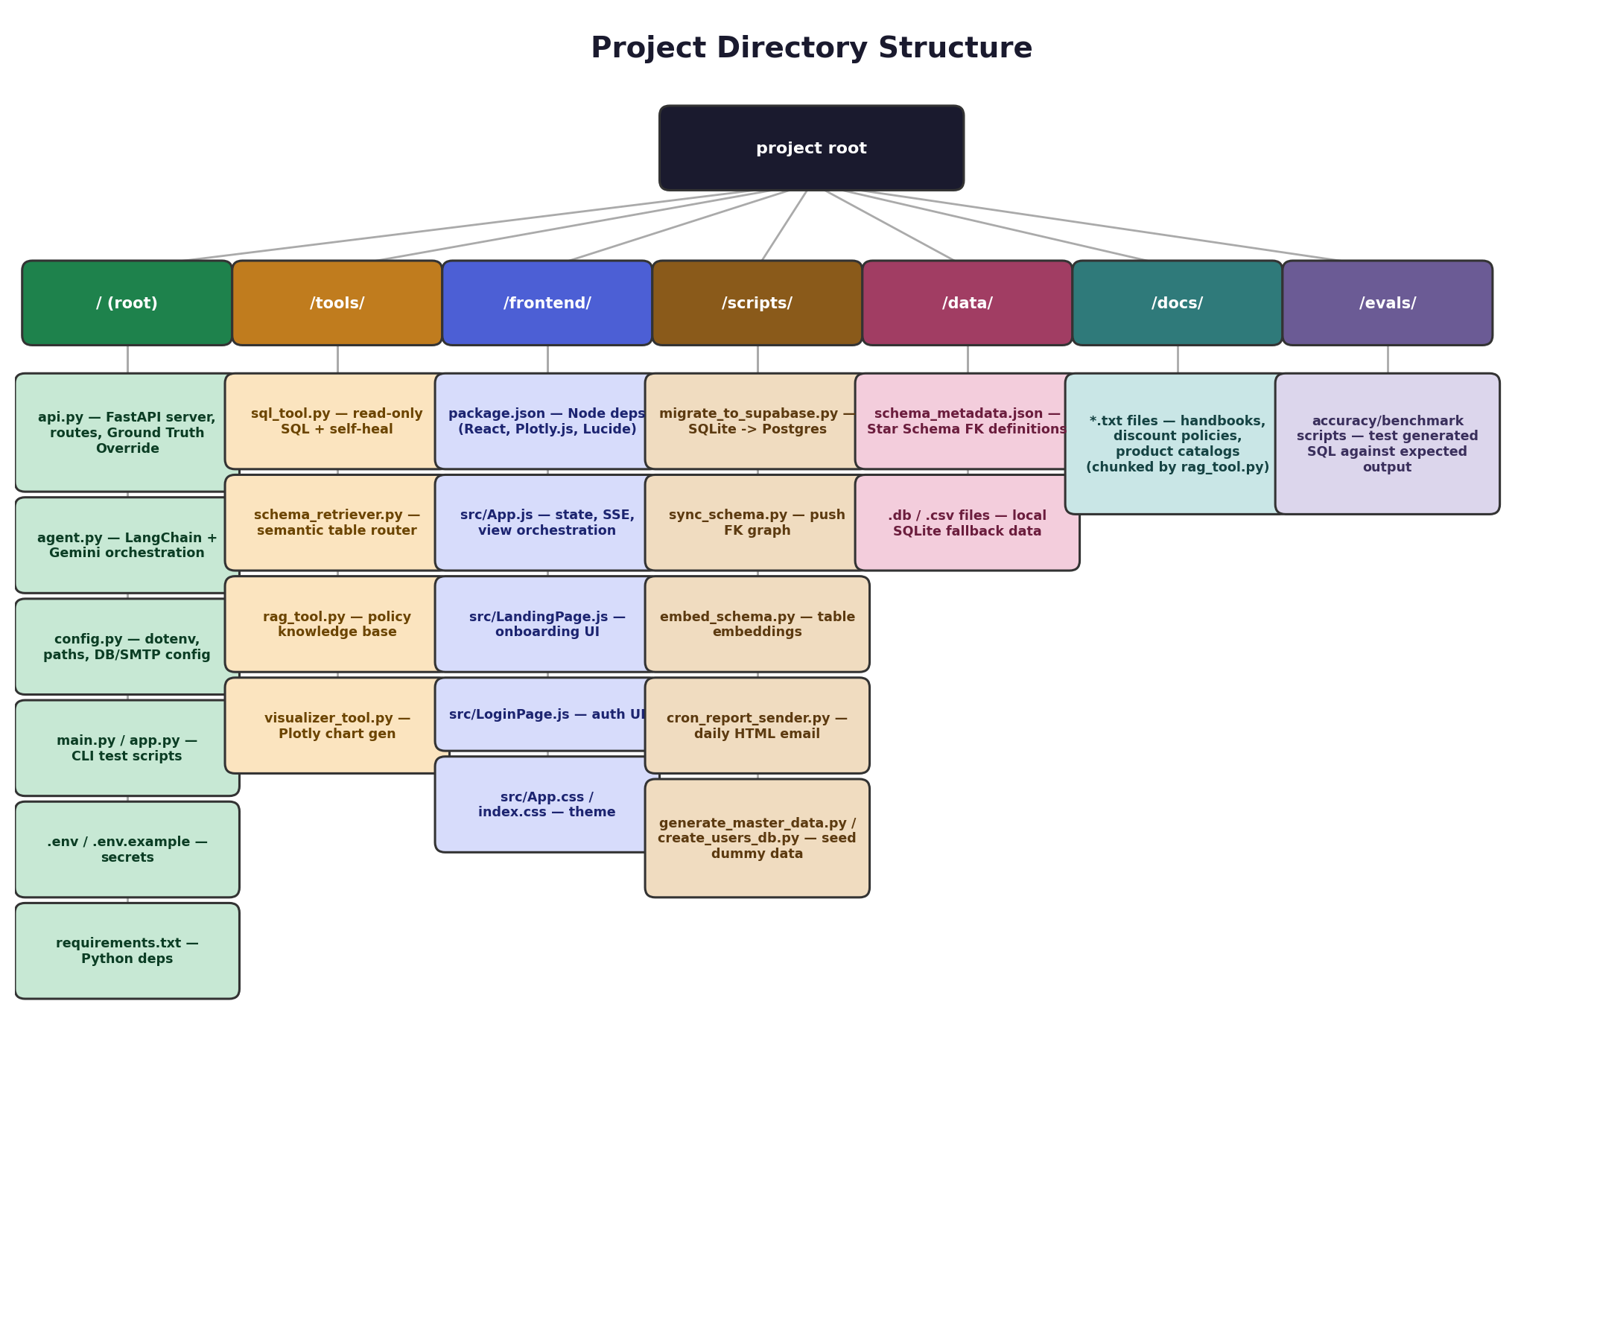
Figure 1 — Complete project directory structure.

2. Root Directory ( / )
Houses the core backend engine, orchestration logic, and configuration.
File / Item | What it contains
api.py | The FastAPI server. Defines all HTTP routes (/api/chat/stream, /api/tables, /api/report/generate, etc.). Handles CORS, database connection pooling setup, server lifecycle events (auto-syncing schema on startup), and the critical “Ground Truth Override” logic that intercepts hallucinations before they reach the frontend.
agent.py | The AI Orchestration Engine. Initializes the LangChain agent with Google Gemini Pro, defines the system prompt, binds the specific tools (sql_tool, rag_tool, etc.) to the LLM, and manages conversational memory (ConversationBufferMemory).
config.py | The Centralized Settings Manager. Uses python-dotenv to load environment variables, defines absolute paths for critical directories (DATA_DIR, DOCS_DIR, OUTPUTS_DIR), and configures the Supabase PostgreSQL connection strings and SMTP email credentials.
main.py / app.py | CLI Interface Scripts. Let developers run the AI agent directly in the terminal for testing, without spinning up the FastAPI server or React frontend.
.env / .env.example | Environment variable files. Store secrets like GOOGLE_API_KEY, SUPABASE_DB_URL, and SMTP passwords.
requirements.txt | Python dependencies — e.g. fastapi, langchain, sqlglot, pandas, sqlalchemy.

3. tools/ Directory
Contains the specific “skills” granted to the LangChain AI agent.
File / Item | What it contains
sql_tool.py | The read-only SQL execution engine. Strict regex guardrails block DML/DDL commands. Uses sqlglot to parse the AI's SQL into an AST, cross-references it with live database columns, and uses fuzzy matching to auto-correct hallucinated column names (e.g. quantity → qty). Includes a self-correcting loop that asks Gemini to fix syntax errors up to 3 times.
schema_retriever.py | The Semantic Table Router. Uses pgvector to semantically match a user's question to relevant table descriptions in Supabase. Performs a 1-hop Foreign Key expansion (via schema_relationships) to find related tables, capping context to 8 tables to prevent prompt flooding.
rag_tool.py | The Policy Knowledge Base. Uses pgvector to perform similarity searches over text files in docs/, retrieving chunks of unstructured policy data to augment the AI's context.
visualizer_tool.py | The Chart Generator. Accepts a pandas DataFrame and instructions from the AI to generate Plotly JSON objects (for the UI) or static image files (for email reports).

4. frontend/ Directory
The React-based user interface.
File / Item | What it contains
package.json | Node dependencies: React, Plotly.js, Lucide-React.
src/App.js | The monolithic main component. Manages global React state, handles the SSE connection for the real-time chat stream, and orchestrates transitions between the three main views: Chat View, Data Explorer View, and Dashboard View.
src/LandingPage.js | The UI for the initial welcome/onboarding screen.
src/LoginPage.js | Authentication UI components.
src/App.css & index.css | Vanilla CSS stylesheets defining the premium “glassmorphism” aesthetic, dark themes, flexbox layouts, and micro-animations.

5. scripts/ Directory
Standalone scripts for setup, automation, and database migration.
File / Item | What it contains
migrate_to_supabase.py | Pushes existing local SQLite data into the cloud PostgreSQL Supabase instance.
sync_schema.py | Uploads Foreign Key relationship mappings to the schema_relationships table in Supabase, so all backend instances can perform graph traversal without rebuilding it.
embed_schema.py | Generates high-dimensional vector embeddings for table descriptions and stores them in Supabase for schema_retriever.py to use.
cron_report_sender.py | A background job script that triggers the AI to generate a comprehensive HTML data report and emails it via SMTP.
generate_master_data.py / create_users_db.py | Scripts used to seed local testing databases with dummy retail and user data.

6. data/ Directory
Stores structural metadata and local data files.
File / Item | What it contains
schema_metadata.json | The raw JSON file that manually defines the Foreign Key relationships between tables (the “Star Schema”). sync_schema.py reads this file to populate the cloud database.
.db / .csv files | Various local data files used for the SQLite fallback mode.

7. docs/ Directory
File / Item | What it contains
*.txt files | Unstructured text files — e.g. Employee Handbooks, Discount Approval Policies, Product Catalogs. rag_tool.py chunks and embeds these files so the AI can answer policy-related questions.

8. evals/ Directory
File / Item | What it contains
evaluation scripts | Python scripts designed to test and benchmark the accuracy of the AI — e.g. testing whether the generated SQL structurally matches the expected output without throwing runtime errors.

9. Quick Lookup — “Where do I find…?”
File / Item | What it contains
...an API endpoint | api.py (root)
...how the LLM is prompted / which tools it has | agent.py (root)
...SQL safety / self-healing logic | tools/sql_tool.py
...how tables get selected for a query | tools/schema_retriever.py
...policy document Q&A logic | tools/rag_tool.py
...chart generation | tools/visualizer_tool.py
...the chat UI / SSE handling | frontend/src/App.js
...the FK / Star Schema definition | data/schema_metadata.json
...the daily email report job | scripts/cron_report_sender.py
...secrets / API keys | .env (root, not committed)
...accuracy testing / benchmarks | evals/

